Parrett and Axe CEVA Primary School
Respect Kindness Courage Equality

Behaviour Policy 2025-2028

A Consistent Approach to Behaviour Management

This underpins effective teaching and learning throughout the school. Staff, pupils and parents are all clear about the high standards of behaviour expected of all pupils at all times. As a Therapeutic Behaviour School, our policy is underpinned by the principles of Therapeutic Thinking. This is an approach that prioritises the prosocial experiences of everyone within the school. We promote good behaviour through high expectations, clear policies and a positive ethos which encourages mutual respect between pupils, and between staff and pupils. This is a plan for the majority of children. In addition, some children may require a Therapeutic Behaviour Plan that use strategies that differentiate them from others. They may need a more flexible approach in times of anxiety or as a result of specific circumstances. As our children know that the whole staff team will follow the behaviour policy and specific classroom routines, they feel safe, motivated to learn and they behave appropriately in the vast majority of cases.

What is Therapeutic Thinking?

When we use a therapeutic approach;

- We analyse behaviour rather than moralise about it.
- We look for the root causes from feelings and experiences rather than blanket behaviourist theory.
- We model therapeutic practices with all children, adults in school and parents or visitors from outside.
- Our language is chosen carefully from universal scripts to be outcome and resolution focused rather than emotive.
At Parrett and Axe Primary we firmly believe that;

- Positive experiences create positive feelings.
- Positive feelings create positive behaviour.

Dynamic Definition - The dynamic is everyone affected by the school or establishment supporting the child. At the centre of a school dynamic are those people who are there all the time, including staff and children. The centre of the dynamic ripples out to include parents, extended families, carers, governors, the local community, occasional visitors etc. Every child has a dynamic, every member of staff, every class, every school, simply it means those affected by.
The relationships people have with each other and the study of how these relationships can change. The way in which people react to each other in a particular situation. The interactions of people when they are grouped with others through either choice or circumstance.

Policy Principles

Planning and managing children’s behaviour creates a link between children’s mental health and behaviour. (See DfE White Paper: Mental Health and Behaviour in Schools November 2018).

This policy is based on the rights, responsibilities and needs of individual and groups of pupils.

- We all have the right to feel safe
- We all have the right to work and learn
- We all have the right to be respected
- We all are responsible members of our school community

Aims of this Policy and the Therapeutic Approach

- To promote the inseparable link between teaching, learning and behaviour.
- To improve staff confidence and safety in applying a therapeutic approach within their class dynamic
- To support the inclusion of those pupils with difficult or dangerous behaviours
- To ensure the positive environment for safe learners
- To reduce and eliminate exclusions
We provide pupils with what they need to succeed in their learning. We endeavour to create a culture which inspires a love of learning through emotional and social intelligence and a responsibility of self- discipline and respect for others. This is reflected in our Schools’ vision:

‘Love your neighbour as yourself’

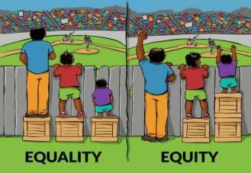

Equality is treating everybody the same.
Equality aims to promote fairness, but it can only work if everyone starts from the same place and needs the same help.

Equity is giving everyone what they need to achieve success. At Parrett and Axe Primary we advocate for each child to receive the resources, experiences, appropriate interventions and support in their learning achieve their full potential.

Equity ≠ Equality.

External discipline is controlling behaviour …Internal discipline is teaching behaviour to create change we need to understand, not simply suppress, the behaviour

How we Teach Behaviour at Parrett and Axe

- Relationships (invest at the start – children should want to do something because of the quality of their relationship with you. The more you know about the child, the more therapeutic you can be)
- Role modelling (this is essential – for e.g., we have to show them how to ‘play nicely’ by playing with them)

• Consistency (not equality)
- Routines (but with flexible thinking referring to individual circumstances and quick wins)
- Prioritising prosocial behaviour (really valued in every child – thanking them, proximal praise)

• Planning alternatives to antisocial behaviour
- Reward and positive reinforcement (should be given freely and unexpectedly, not as a form of bribery)
- Feedback and recognition (give feedback when something has not been asked for – don’t just celebrate the things that are expected (e.g. sticker for holding the door open – this should be the norm))
- Comfort and forgiveness (understanding and know that we will do it differently tomorrow)
- Ignoring (unsocial and low-level behaviours, giving time for unsocial behaviour to stop – do not give attention to these behaviours)
- Positive language (tell children what you would like to see, not what you don’t e.g. Please walk rather than don’t run)
- Restorative Practice (follow up the behaviour, it’s impact and consequences at the appropriate time, after regulation has taken place/provide strategies for further occurrences). Restorative approaches refer to a range of methods and strategies which can be used both to prevent relationship-damaging incidents from happening and to resolve them if they do happen.
We manage the development of internal discipline to gradually replace external discipline – using an approach based on self-direction and self-motivation to replace control measures such as bribery, punishment and control

We have no public methods of tracking behaviour that risk creating negative feelings – children cannot publicly see the judgement of staff and we have adopted private levels of praise. Predominantly children expect feedback and verbal recognition or support (visual reminders such as stickers/certificates are private and not given publicly to compare).

Key Staff and Roles

Simon Smith – Head Teacher, Mental Health Lead, and DSL

Naomi Simmons – SENCO,

Emma House- SEND Governor

Fiona Nash – DDSL

Kathleen Guppy - ELSA

Roles and Responsibilities

Everyone (whole school community) is responsible for:
- Being positive role models
- Ensuring that they are fully aware of the therapeutic behaviour approach that is expected in the Schools.
- Creating a calm and well-ordered environment for teaching and learning and promoting a pride in it.
- Establishing and maintaining high expectations at all times and praising when expectations (however small) are reached or exceeded.
- Creating an atmosphere whereby pupils and adults are treated as individuals whose rights, values, beliefs and cultures are respected.
- Ensuring they strive to develop positive working relationships with all members of the school community by demonstrating mutual respect and tolerance.
- Recognising bullying and unkindness when they occur and taking the necessary steps immediately to deal with unacceptable conduct in a constructive manner (see AntiBullying Policy).
- Consistently promoting pro-social behaviour: “treat others as we would like to be treated”.
- Facilitating learning about relationships and behaviour.
- Trying different approaches to therapeutic behaviour principles to meet the needs of individual children

The Governors and Headteacher are responsible for:
- Monitoring and Evaluating the impact of the Policy.
- Ensure there is a Therapeutic tutor in school that can offer CPD to all staff.
- Regular CPD relating to behaviour throughout the year.

Teachers are responsible for:
- A positive school ethos by establishing a happy, safe, secure and well-maintained school environment.
- Ensuring that no pupil will be discriminated against race, religion, culture or other individual need and ensuring the safety of all.
- Regular and clear communication with parents about the role they are expected to play in the development of their child’s behaviour at school.
- Effective monitoring and review of therapeutic behaviours throughout the school.
- Recording and monitoring incidents of a serious nature, taking steps to ensure that they do not re- occur.
- Regular training on a whole school basis and for individuals both as part of the school’s induction process and as part of an individual’s training needs. Teaching and nonteaching staff are responsible for:
- Using positive therapeutic behaviour techniques to encourage socially responsible behaviour.
- Pro-actively seeking ways to avoid difficult and dangerous behaviours arising through priming children about expectations and pre-empting, where possible, when situations may arise.
- Recognising and valuing the needs of individual pupils according to social and academic ability and aptitude to enable them to achieve their full potential.
- Ensuring that children behave in a way that is safe for themselves and others by taking action to prevent accidents and difficult/dangerous behaviours before they occur (e.g.
stopping a ‘silly’ game from continuing) both in the classroom and playground.
- Enabling pupils to take an increasing responsibility for their own learning and conduct.
- Implementing behaviour guidelines using the school systems for rewards and consequences - taking consistent and firm action to prevent one pupil from taking away another pupil’s right to learn or feel safe.
- Ensuring there is effective supervision of all pupils at all times (i.e. ‘walking’ the playground and ensuring pupils are not left anywhere without supervision).
- Providing opportunities for pupils to share their beliefs of what is acceptable and unacceptable behaviour and creating a class charter/code of conduct which will permeate to whole school
- Practice in the shape of “Rights and Responsibilities” (this needs to be re-enforced each half term or whenever appropriate).
- Liaising with parents about matters which affect their child’s happiness, progress and behaviour by keeping the parents well informed and attending meetings when requested.
- Planning a programme of Religious Education and PSHE (including Circle Time) to promote pro- social behaviour.
- Ensuring Circle Time activities are used regularly and robustly to avoid difficult and dangerous behaviours, to help children learn how to behave appropriately in social environments and how to deal with difficult and dangerous behaviours.
- Ensuring that new pupils understand the procedures and guidelines that are in place.
- Take part in continued CPD for behaviour and the Therapeutic Thinking approach.

Parents are responsible for:
- Accepting, contributing and supporting the school’s codes of behaviour and therapeutic approach for staff and pupils.
- Accepting responsibility for the conduct of their children and offering encouragement or sanctions when appropriate.
- Agreeing to and signing the Home School Agreement when their child joins the school.
- Liaising about matters which affect their child’s happiness, progress and behaviour by keeping the school well informed about situations at home that could affect their child’s behaviour in school and attending meetings when requested.

Pupils are responsible for:
- Following school rules and guidelines.
- Becoming increasingly responsible for the school environment and for their own learning and behaviour.
- Taking responsibility for their own actions and knowing the consequences they will have.
- Showing respect for each other and for each other’s property and resources as well as for school property.
- Taking a pride in their learning, actions and appearance.
- Valuing each other’s opinions.

Therapeutic Process – monitoring, assessment and evaluation

At Parrett and Axe we use a graduated approach to behaviour that all members of staff must follow when dealing with any incidents of behaviour (Appendix 1). It is split into three main sections: Universal, targeted and specialist provision. The school also use the Therapeutic Behaviour Flow Chart (Appendix 2) alongside the graduated approach.

Universal
Most incidents of behaviour will fall into this category and can be dealt with using prosocial behaviours, calm scripts and the use of reflect and reset where a member of staff talks to the child or children in a positive way and model expected behaviour.

Targeted
If there are repeated incidents of antisocial behaviour more extreme examples then a targeted response may be required. The first step is notify the SENCO and Head Teacher and to use the Early Prognosis Tool (Appendix 3). This tool gathers together all the information from home, school and the community in order the give an understanding as to why these behaviours are occurring and what the function of the behaviour is (sensory, attention, tangible gains or escape and avoidance). This allows teachers to come up with a hypothesis for the behaviour and come up with in order to progress back to the use of prosocial behaviour.

This will then result in an APDR (Assess, Plan, DO, Review) for behaviour being created. This will get the views of parents and pupils alongside those of members of staff. Targets are then set and reviewed on a monthly basis with parents to track progress.

As part of the targeted provision ELSA or Forest School can be offered.

Specialist
If behaviour targets are not being met or if behaviour escalates then specialist provision may be required. Teachers will update the early prognosis tool if there have been changes and then move onto completing a risk calculator (Appendix 4) to determine who is at risk from the behaviour and then the behaviour checklist (Appendix 5) which will include any intervention or differentiation that is needed to support the child. Finally, anxiety mapping (Appendix 6) will also be undertaken over time. All the analysis will go into creating a behaviour plan which can include outside agency or specialist support from Dorset Services. This could include Early Help, behaviour specialist teacher, bereavement services.

Types of Behaviour

Behaviour is defined as anything a person says or does and everything we see and hear. It is a sliding scale from the most prosocial to the most extreme antisocial. Behaviour takes on additional relevance when we consider the impact it has on ourselves and others.

“You can’t teach children to behave better by making them feel worse. When children feel better, they behave better.”

Prosocial
This relates to behaviour which is positive, helpful, and values social acceptance. It is behaviour that is characterised by a concern for their rights, feelings and the welfare of others. It also benefits other people and society. These behaviours can be defined as the ‘absence’ of antisocial or unsocial behaviour. Examples of this could be:
- Being gentle
- Being kind and helpful
- Working hard
- Looking after property (both theirs and schools)
- Listening to others
- Being honest

Unsocial (difficult) and Anti-social Behaviour (dangerous)
This relates to behaviour that causes harm to an individual, the community or to the environment. It is also likely to cause injury, harassment, alarm or distress and violates the rights of others. Below are some examples of feelings linked with anti-social behaviour.

Examples of unsocial behaviour could be:
- Leaving their desk without permission
- Leaving the carpet during input/story without permission.
- Refusing to complete the work set
- Choosing to do another activity than the one the class are doing
(reading/drawing on whiteboard etc)
- Rocking on their chair
- Calling out/talking to a friend Not listening to instructions
- Playing/fiddling with equipment

Examples of antisocial behaviour could be:
- Aggressive shouting/calling out disruptively Continued interruptions
- Swearing
- Answering back, mimicking Name calling
- Lying
- Refusal to carry out an adult’s request Distracting and/or disrupting others’ learning by shouting, banging, making noises Throwing small equipment
- Leaving the classroom without permission Damage to property/pushing over furniture Stealing

- Leaving the school building
- Leaving the premises
- Spitting (directly at another)
- Pinching, hair pulling, hitting, kicking, fighting, biting
- Throwing furniture
- Verbal bullying (see Bullying Policy for definition)

Conscious and Subconscious Behaviour

When assessing the behaviour of individuals we need to understand whether the behaviour is classed as conscious or subconscious.

Conscious
Present without any thought or planning; a behaviour a person is unable to contain - (unable to moderate or self-regulate).

Subconscious
A result of thought and planning; a behaviour chosen by the child in order to secure a desired outcome or meet a specific need - (unwilling to moderate or self-regulate)

Risk Calculator and Checklist
As mentioned in the behaviour flow chart, teachers will complete both a risk calculator (Appendix 4) and a behaviour checklist (Appendix 5) in order to come up with strategies to support a child displaying these types of behaviour.

Use of Reasonable Force

In the vast majority of situations, even of dangerously anti-social behaviours, reasonable
force (according to the ‘Guidelines of Reasonable Force’) will be a last resort. However, it may be necessary to enforce restraining techniques if a child/adult is in immediate danger or if there is significant damage to property. If reasonable force has had to be used, this will be documented factually and parents and head teacher notified.

Partnership with Parents

We work closely with all parents. We listen to them and we give them feedback about their child’s behaviour, letting them know about good days as well as bad ones through
link books and other forms of communication. We work closely with colleagues from other
agencies in the best interests of individual children with the consent of parents. APDR’s including behaviour related targets are drawn up when required, reviewed each term or sooner in partnership with parents as well as the staff team.

The standard of behaviour expected of all pupils is included in our Home School Agreement which all parents are requested to sign following their child’s admission to our school.

Rewards and Sanctions

Rewards
Rewards can take many forms but the most important thing is that they are applied appropriately, consistently and fairly. Examples used in our school include:

- Sticker charts linked to the school; values of respect, equality, courage and kindness. These are given out at lunch to promote prosocial behaviours.
- From Chesil up to Lulworth, children are given DOJO and house points for many different things including working hard, participation in lessons, group work and prosocial behaviours.
- Whole class rewards are given after reaching each 1000 Dojo’s
- Head Teachers Stickers are awarded by the Head Teacher for outstanding work and effort each day. When you get a sticker you are entered into a raffle to win a small prize given out each week in Celebration Worship
- Celebration Worship occurs every Friday and certificates are given out for each class along with Lunch Time Awards. Parents are welcome to attend.

Sanctions
When antisocial behaviour is observed, sanctions will be applied consistently and fairly as outlined below:
- Verbal Warning
- Within a lesson, the child will be asked to move seats.
- If this doesn’t resolve the behaviour teachers will follow the therapeutic approach using the scripts that are available (CALM, WIN and COACH).
- Yellow and red cards may be used with harder consequences.

Consequences
Consequences are what we do to children as a result of behaviour. They are there to children learn and enable a change in behaviour from the antisocial to the prosocial. There are two different types of consequence. At Parrett and Axe we ensure that there is a logical consequence to antisocial behaviour.

• Protective
Protective consequences remove freedom for a child in order to keep them and others safe.

• Educational
Teaching and learning of why a behaviour took place in order to return freedom to a child.

Outside Agency Support

We are able to access when necessary the following agency support:

PFSA (Family Support Worker)
If required, the school can refer to a family support worker, who will help with behaviour in the home.

Behaviour Support Specialist
As part of the behaviour plan the school can ask for advice from a member of the Dorset Specialist Teacher Service. They will come in, observe the child during the school day and then help come up with strategies and targets. This comes under specialist support

Mosaic
Mosaic are a charity that support children with bereavement and behaviour that stems from it. They offer counseling in school time on a 1:1 basis and will make suggestions for class teachers.

In the past we have also had support from Relate Counseling.

Exclusions

The Head Teacher should consider what extra support might be needed to identify and address the needs of pupils from these groups in order to reduce their risk of exclusion.

When establishing the facts in relation to an exclusion decision the Head Teacher must apply the civil standard of proof. The head should accept something happened if it is more likely to have happened than it did not happen.

Internal Inclusion
Will be considered where behaviour systems are not helping to change the pattern of behaviour. This will follow a conversation with parents.

External Inclusion
Will be considered for incidents of serious violence or continued disruption/all of the above have failed to change the behaviour.

In these cases, the national guidelines will be followed, particularly with regards to recording and reporting.

Pupil Transitions

We pay particular attention to transition periods in our school, as they enter the Foundation
Stage, as they move onto new classes and ability groups and as they prepare to move on to
Key Stage 3. The SENCO and EYFS teachers contact preschools in the summer term to discuss pupils and any extra transition or support that might be required before they start school. There is a 6-week transition period, where new pupils visit for an afternoon settling in session with their peers.

In Year 6, once secondary school places have been finalised, the SENCO will contact schools to arrange any extra transition. Beaminster School have a link TA who will come in to school in the summer term, talk with teachers and pupils about transition and support then until Christmas in Year 7.

At Parrett and Axe staff understand that moving to a new class can be a daunting experience for some. We offer a transition session for any child that may need it at the start of the Autumn term. Children and parents are invited in to their new class, where they have opportunity to talk to staff, explore the classroom and reacquaint themselves after the summer holidays without everyone there.

Date Adopted: October 2026
Approval Committee: FGB
Reviewed by Governing Body Date of next review: October 2028

Graduated Response for Behaviour

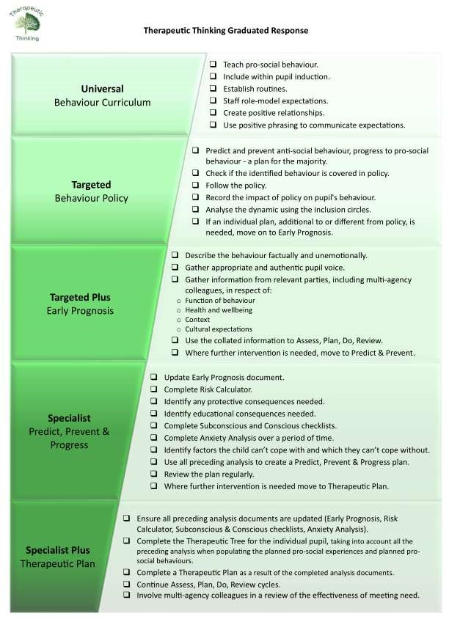

Behaviour Flow Chart

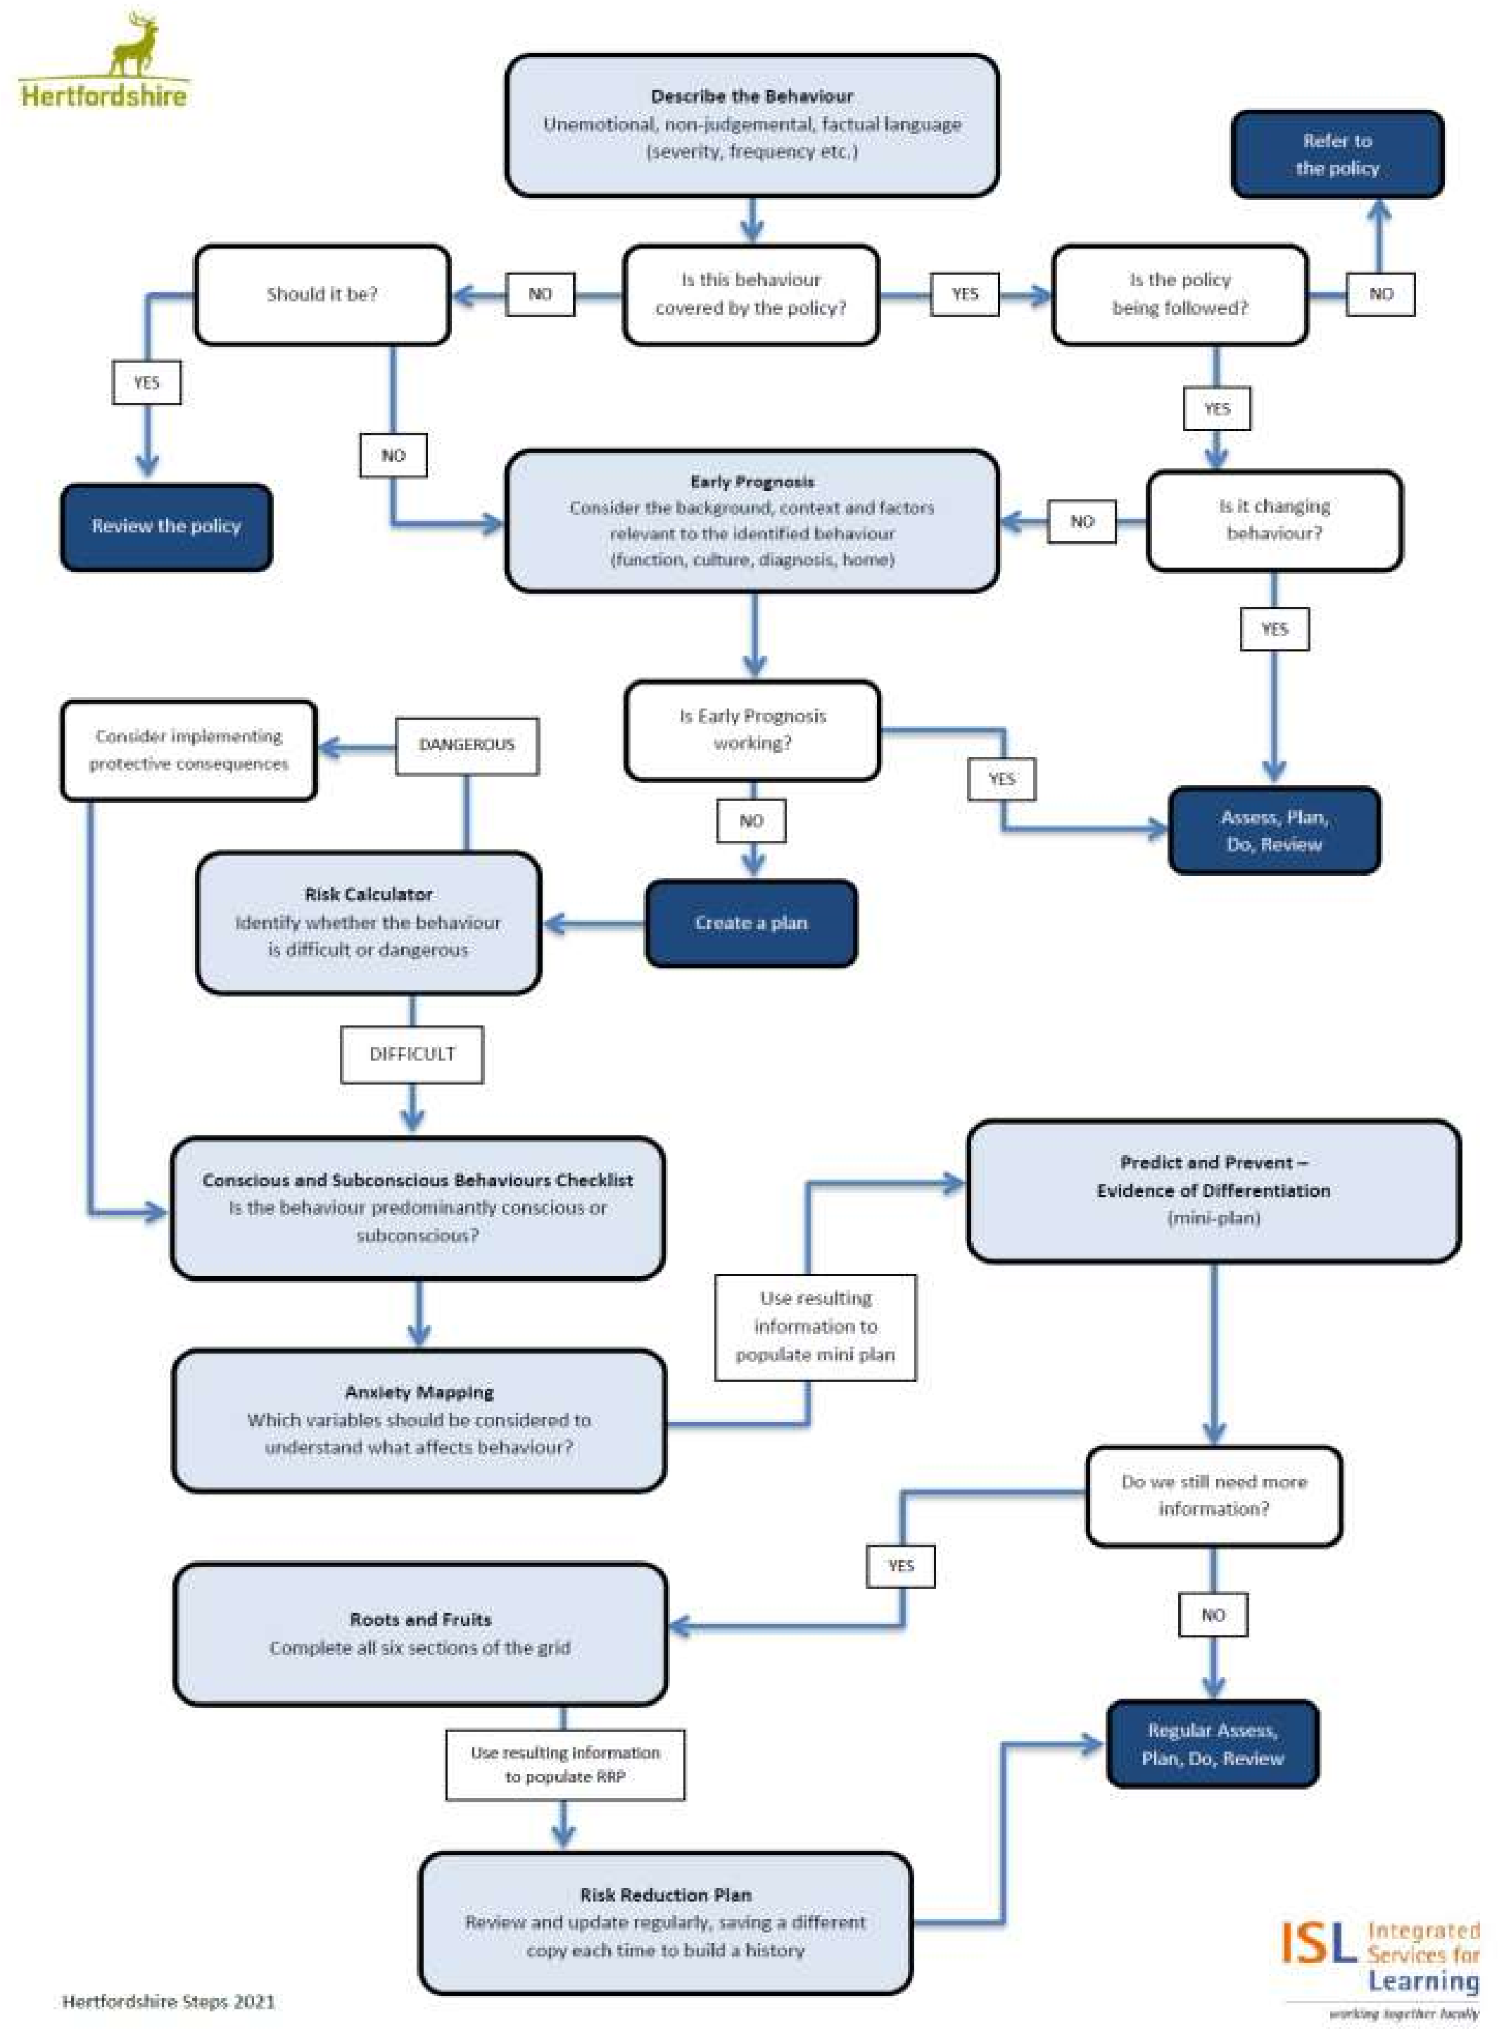
Appendix 3

Risk Calculator

Risk Assessment Calculator

Name
DOB
Date of Assessment

Harm/Behaviour | Opinion  Evidenced  O/E | Conscious  Sub-conscious  C/S | Seriousness  Of Harm  A  1/2/3/4 | Probability  Of Harm  B  1/2/3/4 | Severity Risk  Score  A x B
Harm to self
Harm to peers
Harm to staff
Damage to property
Harm from disruption
Criminal offence
Harm from absconding

Seriousness
1 | Evidence of upset or disruption.
2 | Evidence of needing support internally from our school resources – e.g first aid, nurture, budget allocation.
3 | Evidence of needing intervention from external agencies outside of school resources – e.g. hospital, professional counselling or group work, insurance claim.
4 | Evidence of harm that cannot be resolved e.g. disability, sectioned mental health, loss through arson.
Probability
1 | Yearly or less. No identified triggers remain. There is evidence of historical risk and no evidence of current risk.
2 | Monthly or less. The risk is reducing but remains relevant, the context has changed to make a reoccurrence less likely.
3 | Weekly or less. The risk of harm is more likely than not to occur again.
4 | Daily or constantly. The risk of harm is persistent.

Risks which score 6 or more (probability x seriousness) should have strategies listed on the plan
Conscious and Subconscious Analysis Checklist

Subconscious

Question & Response | Differentiation / Scaffolding / Responsive Teaching
Is the behaviour medical?

Is the behaviour habitual?

What is causing the fear?
(topic, adult, time, activity, peers, transition, noise etc)

What is causing the anger?
(topic, adult, time, activity, peers, transition, noise etc)

What is causing the confusion?
(topic, adult, time, activity, peers, transition, noise etc)

What is causing the embarrassment?
(topic, adult, time, activity, peers, transition, noise etc)

What is causing the anxiety?
(topic, adult, time, activity, peers, transition, noise etc)

What is overstimulating or overwhelming?

Conscious

Question & Response | Differentiation / Scaffolding / Responsive  Teaching  (What are you doing to support)
What is the desired outcome of this behaviour?
(perceived gains)
What is the motivation to behave anti-socially?
(Why do they believe antisocial behaviour will be successful?)
Why is there no motivation to behave prosocially?
(What is supporting them to believe prosocial behaviour will be successful?)
What are the expected consequences?
(Why does the child choose the behaviour, when they are aware of the consequence? Are consequences relevant and or consistent?)

Key Language Definitions

- Anti-social Behaviour: Behaviour that causes harm to an individual, a group, to the community or to the environment.
- Behaviour: Everything a person says or does. The spectrum of behaviour goes from extreme pro-social to extreme anti-social behaviour. A behaviour policy should increase prosocial behaviour and reduce anti-social behaviours through planned responses.
- Being Therapeutic: An approach to behaviour that prioritises the pro-social feelings of everyone within the dynamic. A school’s policy establishes the methodology by which prosocial behaviour replaces anti-social behaviour through planned and sustained pro-social experiences.
- Bribery: The threat or action of withholding of desirable objects or experiences until the child has completed the task or activity dictated by an authority.
- Conscious behaviours: Those that are the result of thought and planning; a behaviour chosen by the child in order to secure a desired outcome or meet a specific need.
- Consequence: A logical, explainable response to a pro-social or anti-social behaviour. A consequence is a logical or natural outcome of something occurring earlier; a conclusion reached via reasoning. Consequences are designed to help children learn and develop prosocial behaviour transferable to all contexts.
- Dangerous behaviour: That which is anti-social and will predictably result in imminent injury or harm (the level of injury and harm that constitutes the label dangerous should be defined within policy). This includes harm to self or others, damage to property or behaviour that would be considered criminal if the person was the age of criminal responsibility, such as racist abuse. Except within an unpredictable first manifestation, the behaviour described as dangerous will be supported by evidence of severity and frequency of outcomes such as ‘three children required first aid for minor bruising as a result of Jane’s kicking’.
- Difficult behaviour: That which is anti-social, but not dangerous. Difficult behaviour should be acknowledged in terms of context: ‘Daniel continually shouting out is difficult within a group teaching activity’.
- Dynamic: Any group of people brought together through choice, circumstance or obligation.
- Equality: Affording people the same equal status, rights, and opportunities.
- Equity: The differentiated measures to provide equal opportunities.
- External discipline: Authoritarian control of behaviour outcomes and achievement using threat and bribery. Often imposed by adults with the intention of generating a disincentive or a motivation where the child has no investment in the task or required behaviour.
- Externalising: When a person’s natural response to anti-social feelings is to act on the world around them, which can lead to physical and verbal responses that affect the wellbeing of others. Examples include fighting, bullying, property damage etc.
- Extrovert: A person who is naturally collaborative and competitive and tends towards social interaction. Extroverts seek and are motivated by public recognition.
- Internal discipline: Participate, contribute, and achieve, independent of external control or competition, where behaviour outcomes and achievement are controlled by the individual’s motivation.
- Internalising: When a person’s natural response to anti-social feelings is to withdraw from the world around them. This can impact the wellbeing and opportunity of the individual concerned and result in refusal to communicate, self-isolation, school refusal, self-harm etc.
- Introvert: A person who is naturally a quiet and reserved individual. They do not generally seek out attention or social interactions and tend to avoid public recognition and attention.
- Pro-social Behaviour: Relating to behaviour which is positive, helpful, and values social acceptance.
- Punishment: The imposition of an undesirable or unpleasant experience upon a group or individual, meted out by an authority. Punishment is designed to suppress and control behaviour within a specific context.
- Reward: A desirable object or experience given to celebrate outcomes already achieved.
- Subconscious behaviour: That which is present without any thought or planning; a behaviour a person is unable to contain.
- Unsocial Behaviour: Not enjoying or needing to behave sociably in the company of others, but not to the detriment of others. This includes quiet communication of anti-social feelings.

