
Parrett and Axe CEVA Primary School
Respect Kindness Courage Equality

Complaints Policy
2025-26

Contents
Introduction 2
What is a complaint? 2
How to make a Complaint 2
Who can make a Complaint? 2
Anonymous Complaints 3
Complaints received out of Term Time 3
Principles of the Procedure 3
Scope of this Complaint Procedure 3
Concurrent Considerations 4
Resolving Complaints 4
Informal Complaints or concerns 4
Formal Complaints Procedure – overview 4
Detailed Procedure 5
Stage 1 – Complaint Heard by Headteacher 5
Stage 2 – Complaint Heard by the Chair of Governors 5
Stage 3 – Complaint Heard by the Governing Body’s Complaints Review Panel 5
Recording 6
Publicity 7
Monitoring of the Procedure 7
Useful Contacts 7
Appendix 1 - Flow Chart of Formal Process 8
Appendix 2 -Timescales Update and remove informal stage 9
Appendix 3 - Roles and Responsibilities 10
The Complainant 10
The Complaints Co-ordinator 10
The Investigator 10
The Panel Clerk (this could be Clerk to the Governors) 10
The Panel Chair 11
Panel Member 11
Appendix 4 - Checklists 12
Meeting with Complainant 12
Interviewing: - 12
Children/young people 12
Staff 12
Complaints Panel Checklist 13
Appendix 5 - School Complaint Form 14
Appendix 6 16
Policy for Unreasonable Complainants/Harassment in Schools 16
Aims of the policy 16
Definition of Unreasonable Complainant 16
Action to be taken by the school 17
Review 17

Introduction

Governing Bodies of all maintained schools and maintained nursery schools in England are required, under Section 29 of the Education Act 2002 to have in place a procedure to deal with complaints relating to the school and to any community facilities or services that the school provides. The law also requires the procedure to be publicised.

The Secretary of State has direction making powers under sections 496 and 497 of the Education Act 1996 and although they are not under a duty to intervene in every case that is brought to their attention, they must always consider whether, in light of the information provided to them by a complainant, they should exercise their powers.

Individuals contacting the local authority regarding a school complaint are advised to contact the school directly. The local authority can also provide advice and support to Headteachers and governors in the operation of their complaints procedures through the Schools’ Complaints Service available from April 2013.

Whilst schools are free to adopt this policy in it’s entirety they must tailor it to their own requirements, failure to do so could result in the DfE finding the school to be in breach of legislative requirements.

What is a complaint?

A complaint may be generally defined as ‘an expression of dissatisfaction or disquiet which requires a response’.

Informal complaints: Parrett and Axe CEVA Primary School takes informal concerns seriously and will make efforts to resolve matters earliest stage possible.

Formal complaints - This formal procedure will be invoked when initial attempts to resolve the issue are unsuccessful and the person raising the concern remains dissatisfied and wishes to take the matter further.

How to make a Complaint

Formal complaints should be made in the first instance, to Clerk to the Governors, School Complaints Co-ordinator. A complaint can be made in person, in writing or by telephone and you will be asked to complete a complaints form (Appendix 5). The Complaints Co-ordinator will record the date the complaint is received and will acknowledge in writing (letter or email) receipt of the complaint within 3 school days.

Who can make a Complaint?

Any person may make a complaint to the school if the school is directly responsible for the issue being complained about. It is not limited to parents with children registered at the school and schools cannot refuse to deal with a complaint once the child has been removed from the school register.

Anonymous Complaints

The Complaints Co-ordinator in conjunction with the Headteacher and Chair of Governors will determine whether the gravity of an anonymous complaint warrants its investigation.

Complaints received out of Term Time

Complaints made outside of term time will be deemed to have been received on the first school day after the holiday period.

Principles of the Procedure

An effective complaints procedure shall: -

- Not exclude any group with protected characteristics from making a complaint.
- Encourage resolution of problems by informal means wherever possible.
- Be easily accessible and publicised.
- Be simple to understand and use.
- Be impartial.
- Be non-adversarial.
- Allow swift handling with established time-limits for action and keeping people informed of the progress.
- Ensure a full and fair investigation by an independent person where necessary;
- Respect people’s desire for confidentiality.
- Address all the points at issue and provide an effective response and appropriate redress, where necessary.
- Provide information to the school’s senior management team so that services can be improved (i.e. learning from feedback).
- Have due regard to the principles of the Equality Act 2010 and how they impact upon schools, parents, carers and children/young people.

Scope of this Complaint Procedure

This procedure covers all complaints with the exceptions listed below for which there are separate (statutory) procedures.

This policy does not cover the following issues: -
- admissions to schools:
- exclusion of children/young peoples from school;
- statutory assessments of special education needs;
- school re-organisation proposals subject to statutory procedures;
- matters likely to require a Child Protection Investigation;
- whistle-blowing;
- staff grievances and disciplinary procedures;
- complaints about services provided by other providers, such as contractors and other Council service units.

Complaints that have already been investigated cannot be considered again. Legal, safeguarding or disciplinary proceedings may take precedence over complaints procedures and timescales.

Concurrent Considerations

Legal, safeguarding or disciplinary proceedings may take precedence over complaints procedures and timescales.

If there is a risk that dealing with a complaint might prejudice a concurrent consideration, the complaints procedure will be suspended until the concurrent consideration is concluded. The Complaints Co-ordinator will write to the Complainant explaining the reason for the decision and the nature of the concurrent consideration. Once the concurrent consideration is concluded, the complaint can be investigated as appropriate.

Resolving Complaints

At each stage in the procedure, the schools will want to resolve the complaint if possible. It might be sufficient to acknowledge that the complaint is valid in whole or in part. In addition, it may be appropriate to offer one or more of the following:

- an apology;
- an explanation;
- an admission that the situation could have been handled differently or better;
- an assurance that the event complained of will not recur;
- an explanation of the steps that have been taken to ensure that it will not happen again;
- an undertaking to review school policies in light of the complaint.

Informal Complaints or concerns

As stated above, the school takes any concerns or informal complaints very seriously. The school will endeavour to resolve issues informally wherever possible to prevent matters escalating to the formal procedure. If you would like to raise concerns, please start by telling the class teacher or head of year about your concern. This is usually the best and quickest way of resolving issues.

It is recommended that you speak to the class teacher or head of year as soon as possible as this will give all parties the opportunity to discuss your concerns.

The purpose of this discussion should be to establish the issues and to seek a realistic resolution if possible.

Formal Complaints Procedure – overview

If it is not possible to resolve the complaint informally, the complainant should be advised to make a formal complaint. There are three stages to this procedure: -

Stage 1 – Complaint Heard by  Headteacher  If the complaint cannot be resolved informally, then the Headteacher will investigate. | Stage 2 – Complaint Heard by  Chair of Governors  If the complainant remains unhappy or the complaint is about the Headteacher the investigation will be undertaken by the Chair of Governors. | Stage 3 – Complaint Heard by  Governing Body Review  Panel  This will consist of Governors not involved in the complaints process at an earlier stage.

If the complaint is about a Headteacher, then the complaint will automatically be considered at Stage 2.

Detailed Procedure

Stage 1 – Complaint Heard by Headteacher

Formal complaints must be made to Clerk to the Governors, School Complaints Coordinator. A complaint can be made in person, in writing or by telephone. The Complaints Co-ordinator will record the date the complaint is received and will acknowledge in writing (letter or email) receipt of the complaint within 3 school days.

The Headteacher will investigate the complaint and respond to the Complainant within 10 school days of the date of receipt of the complaint. The Headteacher will advise the complainant to contact the Complaints Co-ordinator if they should wish to escalate their complaint to Stage 2.

Stage 2 – Complaint Heard by the Chair of Governors

If the Complainant is dissatisfied with the outcome of the Headteacher’s investigation at Stage 1 and wishes to take the matter further or if the complaint is about the Headteacher, they can ask for the matter to be considered by the Chair of Governors.

The Chair of Governors will acknowledge the complaint within 3 school days. The acknowledgement will include a summary of the complaints procedure and a response date given. This will be within 10 school days. If this date cannot be met, the Complainant will be given an update and revised response date.

The Chair of Governors will provide a formal written response to the Complainant detailing actions taken to investigate the complaint and provide a full explanation of decisions taken and the reasons for them. Where appropriate, it should include details of actions the school will take to resolve the complaint.

The Complainant will be provided with details of how to contact the Governing body if they are not satisfied with the response.

Stage 3 – Complaint Heard by the Governing Body’s Complaints Review Panel

The Complainant must write to the Chair of Governors giving details of the complaint. Complaints must have been considered by the first two stages before proceeding to panel.

The Clerk to the Governors will acknowledge the request in writing within 3 school days and inform the Complainant of the right to submit any further documents or information relevant to the complaint. The panel will not consider new complaints. A deadline for submission of these documents will be 5 working days before the hearing.

The school will submit the Stage 1 and 2 responses (as appropriate) together with any written response from the Headteacher as appropriate. The Headteacher may also invite members of staff directly involved in matters raised by the Complainant to respond personally or in writing.

The Clerk to the Governors must convene the complaints committee elected from the Governing Body. The committee will comprise 3 governors who have had no previous involvement with the complaint. The complaint will not be heard by the entire governing body.

The Complaints Panel will set a timetable for the hearing and will notify the Complainant of this. The review hearing will be heard within 20 school days of receiving the request.

The aim of the panel will be to resolve the complaint and achieve reconciliation between the school and the Complainant if this is possible.

The hearing will be held in private. Any witnesses (other than the Complainant and the Headteacher) should only attend for the part of the hearing in which they give their evidence. Good practice would be that at no point should the Headteacher or the parent/carer be left with the complaint panel without the other being present

Once the panel are satisfied that they have heard all the information they need to make a decision, the Chair of the Panel will explain to the Complainant and the Headteacher that the committee will consider its decision and respond in writing within 15 school days. The Complainant and the Headteacher will then leave.

The panel will then consider the complaint and all the evidence presented. The panel can: -

- Uphold the complaint, in whole or in part.
- Dismiss the complaint, in whole or in part.
- Decide on the appropriate action to be taken to resolve the complaint.
- Where appropriate, recommend changes to the school’s systems or procedures to prevent similar difficulties in the future.

A written response detailing the decisions, recommendations and the basis on which these have been made will be sent to the Complainant within 15 school days. The Complainant must be notified of the right to refer their concerns to the Department for Education if they are dissatisfied with the way their complaint has been dealt with.

Recording

The Complaints Co-ordinator will record all details of the complaint including: -

- Date of receipt.
- Action taken.
- Summary of complaint.
- Brief notes of meetings and telephone calls with the progress of the complaint.
- Ensure that the staff member subject to a complaint is informed as soon as possible.
- Any written response.
- Minutes of any meetings.
- Final outcome.
- Learning from complaints.

All functions of the complaints procedure should be mindful of the requirements of the Data Protection Act, 1998 and the Freedom of Information Act, 2000

Publicity

Details of the school’s complaints procedure can be found on the school website www.mosterton.dorset.sch.uk

Monitoring of the Procedure

The school will monitor the operation and effectiveness of this complaints procedure as well as how information about complaints is being used to improve services and delivery.

Useful Contacts

Complaints Co-ordinator: Clerk to the Governors

Department for Education
https://www.gov.uk/complain-about-school

Appendix 1 - Flow Chart of Formal Process
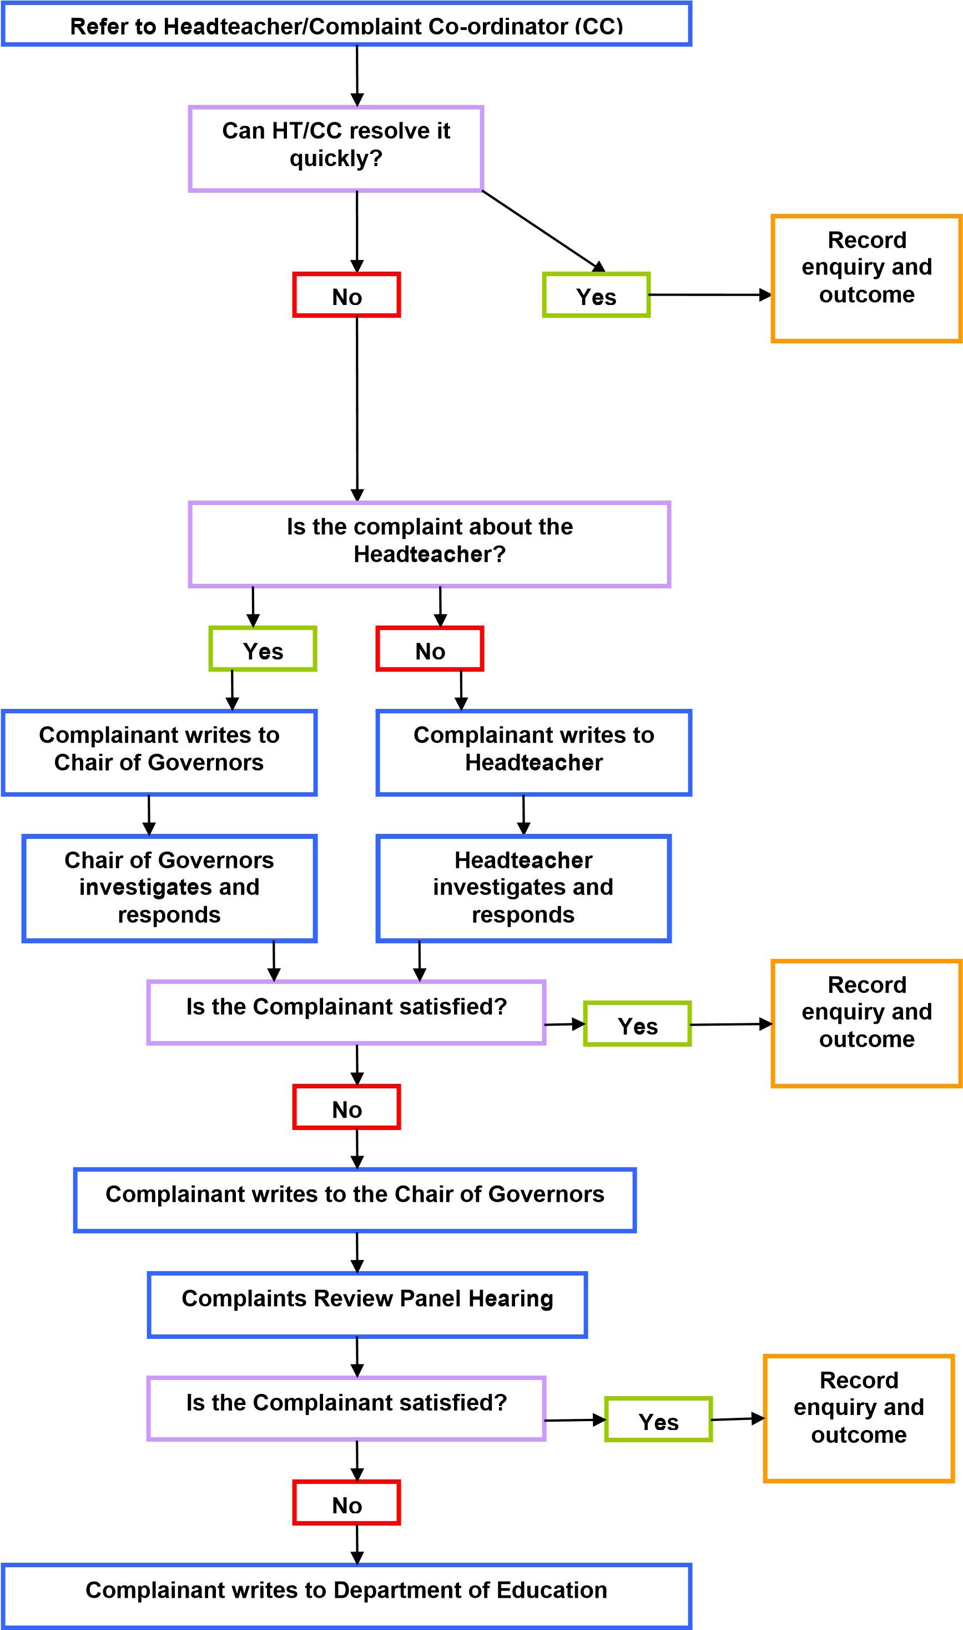

Appendix 2 -Timescales Update and remove informal stage

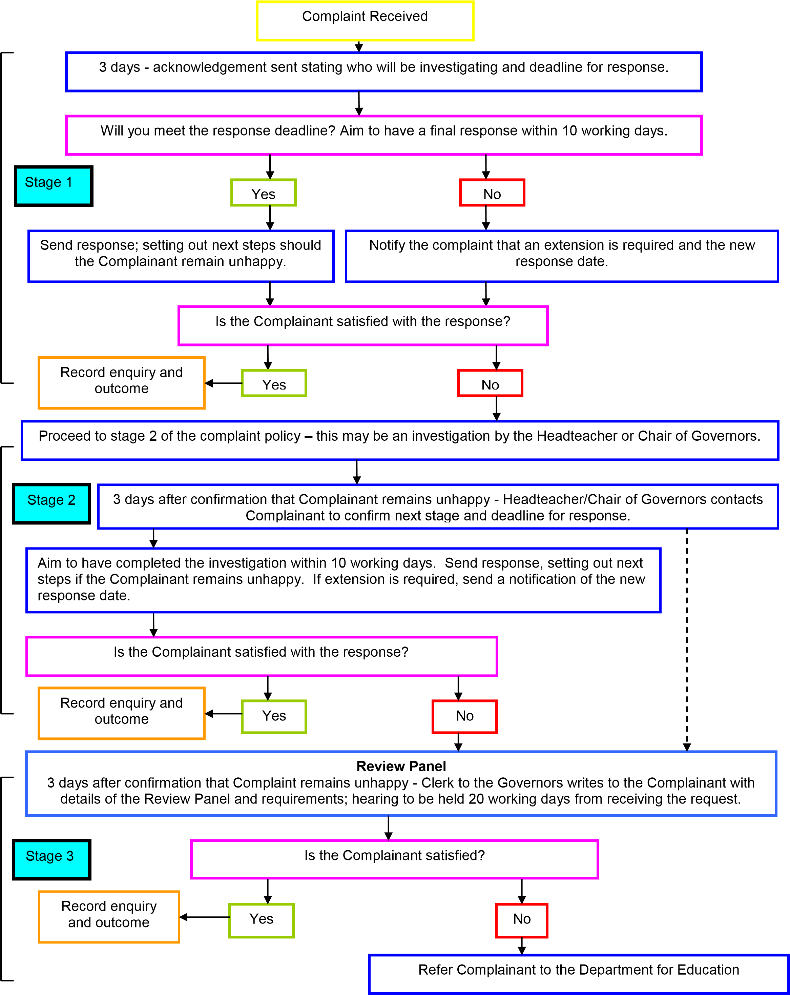

Appendix 3 - Roles and Responsibilities

The Complainant

The Complainant or person who makes the complaint will receive a more effective response to the complaint if he/she: -

- Co-operates with the school in seeking a solution to the complaint.
- Expresses the complaint in full as early as possible.
- Responds promptly to requests for information or meetings or in agreeing the details of the complaint.
- Asks the Complaints Co-ordinator for assistance as needed.
- Treats all those involved in the complaint with respect.

The Complaints Co-ordinator

The Complaints Co-ordinator will: -

- Ensure that all people involved in the complaint procedure should be aware of the legislation around complaints including the Equality Act 2010, Data Protection Act and Freedom of Information Act.
- Liaise with the Staff Member, Headteacher, Chair of Governors and Panel Clerk to ensure the smooth running of the complaints procedure.
- Keep records.
- Be aware of issues regarding: -
  - Sharing third party information.
  - Additional support - this may be needed by complainants when making a complaint including interpretation support.
- Ensure that the Complainant is fully updated at each stage of the procedure and that sometimes letters regarding the progress of the complaint may also need to be translated.

The Investigator

The Investigator is the person involved in Stages 1 and 2 of the procedure.

The Investigator’s role can include: -

- Providing a comprehensive, open, transparent and fair consideration of the complaint through: -

- Sensitive and thorough interviewing of the Complainant.
- Consideration of records and other relevant information.
- Interviewing with staff and children/young peoples and other people relevant to the complaint.
- Analysing information.

- Effectively liaising with the Complainant and the Complaints Co-ordinator as appropriate.
- Identifying solutions and recommending courses of action to resolve problems.
- Be mindful of the timescales to respond to the Complainant in plain and clear language.

The Panel Clerk (this could be Clerk to the Governors)

The Clerk is the contact point for the Complainant for the panel meeting and is required to: -

- Set the date, time and venue of the hearing, ensuring that the dates are convenient to all parties and that the venue and proceedings are accessible.
- Collate any written material and send it to the parties in advance of the hearing.
- Meet and welcome the parties as they arrive at the hearing.
- Record the proceedings.
- Notify all parties of the panel’s decision.
- Liaise with the Complaints Co-ordinator.

The Panel Chair

The Panel Chair has a key role in ensuring that: -

- The meeting is minuted.
- The remit of the panel is explained to the parties and each party has the opportunity of putting their case without undue interruption.
- The issues are addressed.
- Key findings of fact are made.
- Parents/carers and others who may not be used to speaking at such a hearing are put at ease. This is particularly important if the Complainant is a child/young person.
- The hearing is conducted in an informal manner with each party treating the other with respect and courtesy.
- The layout of the room will set the tone and care is needed to ensure the setting is informal and not adversarial.
- The panel is open-minded and acts independently.
- No member of the panel has an external interest in the outcome of the proceedings or any involvement in an earlier stage of the procedure.
- Each side is given the opportunity to state their case and ask questions.
- Written material is seen by all parties. If a new issue arises it would be useful to give all parties the opportunity to consider and comment on.
- Liaise with the Panel Clerk and Complaints Co-ordinator.

Panel Member

Panellists should be aware that: -

- It is important that the review panel hearing is independent and impartial and that it is seen to be so. No governor may sit on the panel if they have had a prior involvement in the complaint or in the circumstances surrounding it. In deciding the make-up of the panel, governors need to try and ensure that it is a cross-section of the categories of governor and sensitive to the issues of race, gender and religious affiliation.
- The aim of the hearing, which needs to be held in private, will always be to resolve the complaint and achieve reconciliation between the school and the Complainant. However, it has to be recognised the Complainant might not be satisfied with the outcome if the hearing does not find in their favour. It may only be possible to establish the facts and make recommendations which will satisfy the Complainant that his or her complaint has been taken seriously.
- An effective panel will acknowledge that many complainants feel nervous and inhibited in a formal setting. Parents/carers often feel emotional when discussing an issue that affects their child or young person. The panel chair will ensure that the proceedings are as welcoming as possible. The layout of the room will set the tone and care is needed to ensure the setting is informal and not adversarial.
- Extra care needs to be taken when the Complainant is a child/young person. Careful consideration of the atmosphere and proceedings will ensure that the child/young person does not feel intimidated. The panel needs to be aware of the views of the child/young person and give them equal consideration to those of adults. Where the child/young person’s parent/carer is the Complainant, it would be helpful to give the parent/carer the opportunity to say which parts of the hearing, if any, the child/young person needs to attend.

NB Governors sitting on the panel need to be aware of the complaints procedure.

Appendix 4 - Checklists

Investigation Checklist

The person investigating at each stage of the complaint will need to:-

- Establish what has happened so far, and who has been involved.
- Clarify the nature of the complaint and what remains unresolved.
- Meet with the Complainant or contact them – see Meeting with the Complainant below.
- Establish the outcomes that the Complainant is seeking and whether these are achievable through the complaints process.
- Interview those involved in the matter and/or those complained of, allowing them to be accompanied if they wish.
- Conduct interviews with an open mind and be prepared to persist in the questioning.
- Keep notes of interviews.

Meeting with Complainant

The investigator will need to: -

- Allow the Complainant to explain how they feel and express any strong emotions – they should feel as if their complaint has been accepted.
- Clarify the complaint and all its individual parts and produce a written record. • Ask what the Complainant is seeking regarding solution or outcomes.
- Check whether the Complainant needs support of any kind, in order to understand the discussion properly.
- Determine whether they need support during the process i.e. an advocate or any accessibility needs such as signer, hearing loop etc.
- Read the background to the complaint and the relevant legal and administrative policies and procedures.
- Consider whether the complaint could be resolved without further investigation.
- Assess whether the complaints procedure is the most appropriate way of handling this complaint.

Interviewing: -

Children/young people

- Children/young people will be interviewed in the presence of another member of staff, or in the case of serious complaints (e.g. where the possibility of criminal investigation exists) in the presence of their parents/carers.
- Care should be taken in these circumstances not to create an intimidating atmosphere.
- Children/young people will be told what the interview is about and that they can have someone with them.

Staff

- Explain the complaint and your role clearly to the interviewee and confirm that they understand the complaints procedure and their role in it.
- Staff are allowed a colleague to support them at their interview. The colleague must not be anyone likely to be interviewed themselves, including their line manager.
- Use open not leading questions.
- Do not express opinions in words or attitude.
- Ask single not multiple questions, i.e. one question at a time.
- Try to separate ‘hearsay’ evidence from fact by asking interviewees how they know a particular fact.
- Persist with questions if necessary. Do not be afraid to ask the same question twice. Make notes of each answer given.
- Deal with conflicting evidence by seeking corroborative evidence. If this is not available, discuss with the Complaints Co-ordinator/ Headteacher/ Chair of Governors the option of a meeting between the conflicting witnesses.
- Make a formal record of the interview from the written notes as soon as possible while the memory is fresh. Show the interviewee the formal record, ask if he has anything to add, and to sign the record as accurate.

Complaints Panel Checklist

The panel will try to ensure that: -

- The hearing is as informal as possible.
- Witnesses are only required to attend for the part of the hearing in which they give their evidence.
- After introductions, the Complainant is invited to explain their complaint, outline their desired outcome and be followed by their witnesses.
- The Headteacher may question the Complainant and the witnesses after each has spoken.
- The Headteacher is then invited to explain the school’s actions, their views on the desired outcomes and be followed by the school’s witnesses.
- The Complainant may question both the Headteacher and the witnesses after each has spoken.
- The panel may ask questions at any point.
- The Complainant is then invited to sum up their complaint.
- The Headteacher is then invited to sum up the school’s actions and response to the Complaint.
- The Chair explains that both parties will hear from the panel within 15 school days.
- Both parties leave together while the panel decide on the issues.

Appendix 5 - School Complaint Form

Please complete this form and return it to Clerk to Governors, Complaints Co-ordinator who will acknowledge receipt and explain what action will be taken.

Your name:
Child/young person’s name:
Your relationship to the child/young person:
Your Address:

Daytime telephone number:

Evening telephone number:

Email:
Please give concise details of your complaint, what you think the School did wrong or did not do. Include dates, names of witnesses etc.

What action, if any, have you already taken to try to resolve your complaint? (who have you spoken with or written to and what was the outcome?).

What do you think the School should do to resolve matters at this stage?
Please list any paperwork you are attaching:

Do you need the paperwork to be returned to you: Yes/No

Signature: ……………………………………… Date: …………………

School Use  Date form received: |  | Received by:
Date acknowledgement sent: |  | Acknowledgement sent by:
Complaint referred to:  Date response sent: |  | Date referred:

Appendix 6

Policy for Unreasonable Complainants/Harassment in Schools

The Headteacher and staff at Parrett and Axe CEVA Primary School deal with specific complaints as part of their day-to-day management of the school in accordance with its Complaints Procedure. The majority of complaints are handled in an informal manner and are resolved quickly, sensitively and to the satisfaction of the complainant.

Parrett and Axe CEVA Primary School is committed to dealing with all complaints fairly and impartially and to providing a high quality service to those who complain and they will not normally limit the contact complainants have with the school. However, there are occasions when complainants behave in an unreasonable manner when raising and/or pursuing their concerns and the school does not expect their staff to tolerate unacceptable behaviour. The school will take action to protect staff from that behaviour, including that which is abusive, offensive or threatening.

In these circumstances the school may take action in accordance with this policy.

Aims of the policy

The aims of this policy are to:

- uphold the standards of courtesy and reasonableness that should characterise all communication between the School and persons who wish to express a concern or pursue a complaint;
- support the well-being of students, staff and everyone else who has legitimate interest in the work of the School, including governors and parents;
- deal fairly, honestly and properly with those who make persistent or vexatious;
- complaints and those who harass members of staff in school while ensuring that other stakeholders suffer no detriment.

Definition of Unreasonable Complainant

Parrett and Axe CEVA Primary School defines unreasonable complainants as ‘those who, because of the frequency or nature of their contacts with the school, hinder our consideration of their or other people’s complaints’.

A complaint can be regarded as unreasonable when the person making the
complaint:-
- Refuses to articulate their complaint or specify the grounds of a complaint or the outcomes sought by raising the complaint, despite offers of assistance.
- Refuses to co-operate with the complaints investigation process while still wishing their complaint to be resolved.
- Refuses to accept that certain issues are not within the scope of a complaints procedure.
- Insists on the complaint being dealt with in ways which are incompatible with the adopted complaints procedure or with good practice.
- Introducing trivial or irrelevant information which the customer expects to be taken into account and commented on, or raising large numbers of detailed but unimportant questions and insisting they are fully answered often immediately and to their own timescales.
- Makes unjustified complaints about staff who are trying to deal with the issues, and seeks to have them replaced.
- Changes the basis of the complaint as the investigation proceeds.
- Repeatedly makes the same complaint (despite previous investigations or responses concluding that the complaint is groundless or has been addressed).
- Refuses to accept the findings of the investigation into that complaint where the school’s complaint process has been fully and properly implemented and exhausted including referral to the DfE.
- Seeks an unrealistic outcome.
- Has a history of making unreasonable complaints.
- Makes excessive demands on school time by frequent, lengthy, complicated and stressful contact with staff regarding the complaint in person, in writing, by email and by telephone whilst the complaint is being dealt with.
- Electronically recording meetings or conversations without the prior knowledge and consent of the other persons involved.

A complaint will also be considered unreasonable if the person making the complaint does so either face to face, by telephone or in writing or electronically: -

- Maliciously.
- Aggressively.
- Using threats, intimidation or violence.
- Using abusive, offensive or discriminatory language.
- Knowing it to be false.
- Using falsified information.
- Acts in a persistent way by: -
  - Sending numerous letters;
  - Making multiple phone calls;
  - Sending multiple e-mails;
  - Leaving multiple voicemails;
  - Sending multiple text messages;
- Publishing unacceptable information in a variety of media such as in social media websites and newspapers.

Action to be taken by the school

Whenever possible, the Headteacher or Chair of Governors will discuss the concerns with the Complainant informally before invoking the procedure. This will be confirmed in writing.
If the behaviour continues the Headteacher will write to the Complainant explaining that their behaviour is unacceptable and is being considered under this policy. The letter will specify what behaviour is unreasonable and asking them to change it. The Headteacher may also specify methods of communication and times in a communication plan.
Any serious incident of aggression or violence the concerns and action will be put in writing immediately and the Police informed.
Any legitimate new complaints will still be considered even if the person making them is, or has been, subject to the Policy for Dealing with Unreasonable Complaints.7.

Review

The School will review as appropriate, and at a minimum once in a school year, any sanctions applied in the context of this policy.

