Corfe Reception Class | Long Term Plan
2026-2027 |     RESPECT COURAGE KINDNESS EQUALITY

 | 7 - Autumn - 7 |  | 6 – Spring - 6 |  | 6 – Summer - 7
Topic | Me in My World  Autumn  Animals and Me | Let’s Celebrate?  Harvest  Materials | Into the Wild  Changing Weather | Once Upon a Time  Planting | The Great Outdoors  Minibeasts  Lifecycles | Stories from Around the World  People who help us/Journeys
Values | Kindness  Courage  Celebrating the uniqueness of every child and valuing differences  Our Class Charter | Respect  Equality  Learning to celebrate special people and special times together. | Kindness  Equality  Adapting stories to learning and bringing stories to life through a range of activities. | Courage  Respect  Celebrating New Life  Looking after each other | Kindness  Equality  Learning about life cycles and change.  Looking after Nature. | Respect Courage Kindness Equality  Learning about different people and communities  Our Journey/Transition
Key Themes | All About Me  Harvest | Bonfire Night, Christmas | Looking after  our world | Fairytales  Growing | Minibeasts  Lifecycles | Journeys  Transition
Fabulous Finish | Self portraits  My Family | Nativity | Penguin Display | ‘The Little Red Hen’  Performance Rap | Park Trip | Farm Trip
Key Texts | 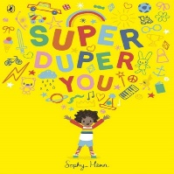 | 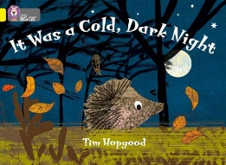 | 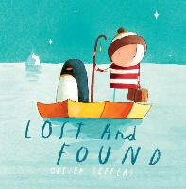 | 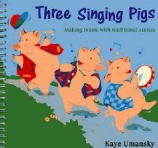 | 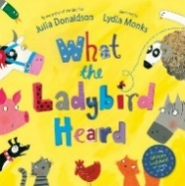 | 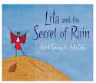
Key Texts | Supa Dupa You  All about Me  Sharing a shell  Elmer  Funny Bones  The Colour Monster | It was a Cold Dark Night  Leaf Thief  Christopher Pumpkin  Christmas Stories  (Harvey Slumfenburger) | The Snow Thief  Lost and Found  The Journey Home  Handa’s Surprise  We’re going on a Bear Hunt | Little Red Hen  The Three Little Pigs  Jack and the Beanstalk  Mother’s Day  Easter | What the Ladybird Heard  Bog Baby  Mad About MiniBeasts  The Very Hungry Caterpillar  Trip to the Park | The Proudest Blue  Lila and The Secret of Rain  The Big Green  We’re Going on Safari  So Much
Other Stories | A range of stories throughout the year to stimulate discussions around; the past, different cultures, countries, beliefs, traditions and celebrations, to develop a deep familiarity with new knowledge and vocabulary
Communication & Language | Through all topics, all events, all routines, all story times and all areas of provision children will be supported with and given opportunities to develop listening skills, learn new vocabulary, learn poems, rhymes and songs, describe events, explain, retell stories
Personal, Social & Emotional Development | Settling In  Jigsaw: Being Me In My World | Jigsaw: Celebrating Differences | Jigsaw: Dreams and Goals | Jigsaw: Healthy Me | Jigsaw: Relationships | Jigsaw: Changing Me  Transition
Physical Development | Fine Motor Skills  Handwriting  Outside Play  Multi Skills (PE Coach) | Fine Motor Skills  Handwriting  Outside Play  Multi Skills (PE Coach) | Fine Motor Skills  Handwriting  Outside Play  Bats and Balls (PE Coach) | Fine Motor Skills  Handwriting  Outside Play  Ball Skills (PE Coach) | Fine Motor Skills  Handwriting  Outside Play  Team Games (PE Coach) | Fine Motor Skills  Handwriting  Sports Day  Outside Play
Literacy Reading | Little Wandle Phonics  Books related to interests and topics  Storytime | Little Wandle Phonics  Books related to interests and topics  Storytime | Little Wandle Phonics  Books related to interests and topics  Storytime | Little Wandle Phonics  Books related to interests and topics  Storytime | Little Wandle Phonics  Books related to interests and topics  Storytime | Little Wandle Phonics  Books related to interests and topics  Storytime
Children will have constant access to books in our book area, through books placed in every area linked to continuous provision and access to the Library at designated times.
Phonics | Little Wandle Phase 2 | Little Wandle Phase 2 | Little Wandle Phase 3 | Little Wandle Phase 3 | Little Wandle Phase 4 | Little Wandle Phase 4
Literacy Writing | Drawing Club  Labels and Captions | Drawing Club  Speech Bubbles Labels and Captions | Drawing Club  Writing Simple Sentences | Drawing Club  Writing Simple Sentences | Drawing Club  Writing Simple Sentences | Drawing Club  Non-fiction Writing  Writing Simple Sentences
 | Children will have constant access to a variety of mark-making materials in indoor and outdoor provision.
Mathematics | NCETM – mastery maths
Understanding the world | Outside Cont Prov  Harvest  Me and My family  My Senses  Autumn  Changes in the weather – Autumn to Winter  Geography  Where in the world do we live? Countries | Outside Cont Prov  Different beliefs & celebrations  Christmas  Bonfire Night  What materials things are made from  Melting and changing state of materials - chocolate  Celebrations  Christmas | Outside Cont Prov  Chinese New Year - different beliefs & celebrations  Polar Animals  Melting Ice/changing state  Winter- Being cold/Hibernation/  migration  Making bread (Shabbat)  Animal Groups  Geography  What are landmarks?  Did a human make it or is it naturally made? | Outside Cont Prov  Different countries  Easter  Planting seeds/growing  Naming flowers, plants etc  Observing similarities and differences in living plants  History  Significant People  Mary Anning, Amy Jonson, Neil Armstrong, Florence Nightingale, Christopher Columbus | Outside Cont Prov  Bug Hunting  Hanukkah – playing different games, trying different foods  Seasons – Spring into Summer -how the weather changes and how the plants and trees look different.  Live Caterpillars Tadpoles  Geography  Draw information from a simple map.  Go on a journey to the park | Outside Cont Prov  Investigations  Colour mixing  Floating and sinking  Push or Pull  Pasta/playdough bridge  Test your boat  Minibeast Investigation  ART  Artist Study -  Giuseppe Arcimboldo (drawing)  Wassily Kandinsky (colour mixing/ paints)  Andy Goldworthy  Paul Klee
Understanding the world | The past – a range of stories throughout the year to discuss differences between the past and present
Expressive Arts and Design | Self portraits  Family portraits  Mark Making  Making area joining techniques | Firework art  Drawing skills – hedgehogs, leaves, pumpkins  Making area joining techniques | Drawing skills – how to draw a penguin  Make a penguin  Making area joining techniques | Drawing skills – farm animals  Make a chick  Easter drawings  Making area joining techniques | Drawing skills – ladybirds, bog baby  Make a ladybird  Make a bog baby  Different materials  Making area joining techniques | Drawing Skills  Making area – junk modelling  Rain sticks  Binoculars  Robots  Colour Mixing
Expressive Arts and Design | Throughout the year children will have opportunities to explore and create using a wide variety of media, in 2D and 3D form, including music and dance.
Music  (Mrs Pittard) | Having fun with our voice | Pitch matching  Finding the pulse | Singing Games and rhymes  Using percussion instruments | Singing Games and rhymes  Dynamics, speed and texture. Rhythms. | Singing Games and rhymes  Music and stories | Singing Games and rhymes  Mark making to to music of different styles
Music  (Mrs Pittard) | Throughout the year regularly sing and learn new songs related to topics and interests.
RE | Understanding  Christianity  Creation | Understanding Christianity  Incarnation | Judaism  Shabbat | Understanding Christianity  Salvation | Judaism  Hanukkah | Creation  Judasim

